# Signals & Systems exam 2023

Af Jesper Bertelsen

Indholdsfortegnelse

Signals & Systems exam 2023 1

Problem 1. ( 20 points ) 2

Problem 2. ( 20 points ) √ 4

Problem 3. ( 20 points ) √ 5

Problem 4. ( 20 points ) √ 8

Problem 5. ( 20 points ) % 11

## Problem 1. ( 20 points )

If there exist some where the signal is periodic.

Is a sin function and has periodicity.

*Ligningen løses for T vha. WordMat.*

So it’s period is:

Has periodicity,

Is a cos function and has periodicity.

Has no periodicity.

## Problem 2. ( 20 points ) √

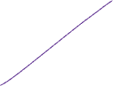

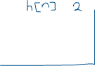

## Problem 3. ( 20 points ) √



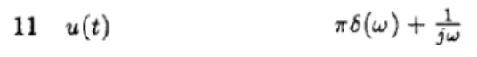

And with the principle of linerarity in the Fourier transform





And time delay



Fourier transform of a unit step function:

=======================================================

=======================================================



As I notice, there are 5 sums of the imaginary part and 1 sum of the real part.

Let me exchange with

There’s a lot of denominators with j in it. Let me for each denominator get rid of these.

===================

===================

Multiplying by the complex conjugate

For the denorminator:

===================

===================

For the last denorminator I realise, that it’s the same except for the denorminator being powered by two and without

===========

===========

Now substituting into the equation:

Now expanding for the other ’s

========================================================

Now looking at the real part:

And the imaginary part:

========================================================

======================================

For the magnitude, pythagoras is used to find it.

======================================

## Problem 4. ( 20 points ) √

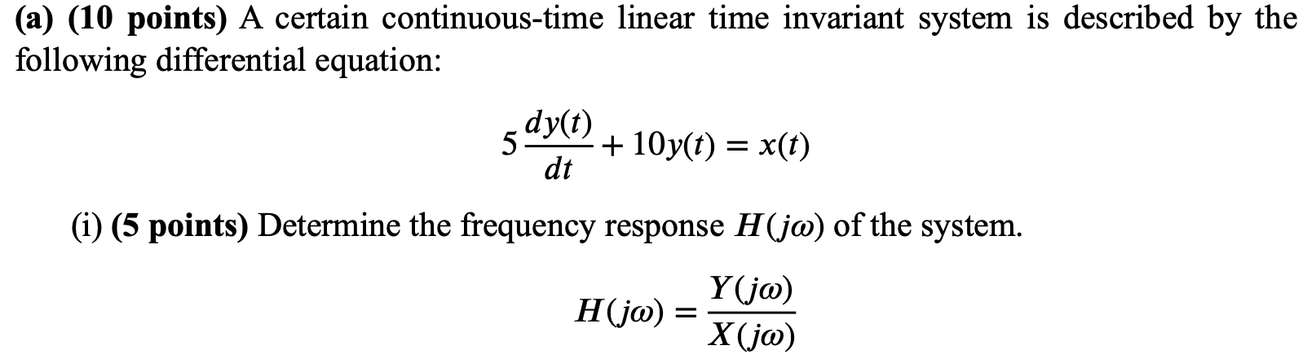

The response of the system can be written as:

And from what I know about convolution, the following transforms can be made:



If we set the signal to be a complex exponential signal given by:

Substituting in the equation:

Which can be simplified to

Then we can solve for

=============

=============

I am using fourier transform to describe these in terms of frequencies:



For time shift of discrete time fourier transforms



And with the linearity principle:



Meaning my equation would look like:

Simplifying with and factoring in terms of



Taking the complex conjugate.

Simplifying for the denominator:

And solving for the enumerator :

Substituting in the equation:

Or in terms of real and imaginary

Taking the absolute of the frequency response means taking pythagoras for the real and imaginary part.

====================================

====================================

I will do no more simplification of that.

The angle can be achieved by taking the invers tan of the y ( imaginary part ) / x ( real part )

==========================

==========================

## Problem 5. ( 20 points ) %



